Earth Day Thematic Unit: Day 1

**Course Data**

**Grade Level**: 3

**Lesson Topic**: Plant a Tree

**Materials**

<http://pbskids.org/eekoworld/index.html?load=environment>

*Be a Friend to Trees* by Patricia Lauber

Green construction paper

Markers

Scissors

Clear tape

**Lesson Objectives**

TSWBAT brainstorm ideas on the benefits of trees.

TSWBAT create a five paragraph letter relating to trees’ benefits.

TSWBAT build an evergreen tree.

TN curriculum standards

**GLE 0401.1.1** Demonstrate knowledge of Standard English usage, mechanics, and spelling.

**GLE 0401.1.3** Demonstrate knowledge of Standard English sentence structure.

**Anticipatory Set/Focus**

Give students 1 minute to brainstorm everything that they know about trees (ABK). Take children on a five minute walk to observe the trees around the school (IAL, RRL). When you get back into the classroom make a list on the board of everything that knew or noticed about trees. Today, we are going to learn about trees just like the ones we saw and are going to plant (LL).

**Essential Question**: Should we help the trees?

**Instruction**

Show students the video about forests on

<http://pbskids.org/eekoworld/index.html?load=environment> and read *Be a Friend to Trees.*

Writing Prompt: You just found out that a lumber company is planning to cut down all of the trees in a nearby forest. The town committee is supposed to vote on the matter next week. You are going to write a five paragraph letter to the committee explaining why they should vote to keep the trees. Be sure to include at least three reasons and explain each of them in detail.

Prewriting- Before you begin, take 3 minutes to brainstorm any ideas. Remember the reasons that you saw in the movie and read about in the book.

You are going to use the ideas that you put down in the brainstorming. Your job with this letter is to try and persuade the committee to save the trees by convincing them that trees are beneficial to humans. Your letter needs to include five paragraphs with at least five sentences each. After you have been writing for ten minutes, I am going to pair you up and let you share what you have with a partner. I will give each partner five minutes to read the papers and share ideas and thoughts. When you have finished the letter, make sure that you go back and check to see that all the words are capitalized that need to be, all sentences are punctuated correctly, and all words are spelled correctly.

**Closure**

Have students put away their writings and finish for home work if needed. Have students create an evergreen (directions below). On the evergreen, they will write one reason why we need trees. Place the trees in the back of the room as a class forest. Use rubric below to assess letters.

Evergreen directions

Fold a piece of green construction paper in half (hamburger way), then cut it in half.

Put the two pieces together, and fold them in half again.

Draw half an evergreen tree opposite the fold.

Cut along the line - you should get two identical trees.

Fold the trees in half, just barely creasing the center line (this is to mark the center of the tree).

Cut a slit along the bottom half of the center of one tree and along the top half of the center of the other tree.

Slip the two trees together along the slits.

Using clear tape, tape the bottoms and tops together (pieces of tape on the bottom and at the top make the tree stand up well and stop the slit ends from flopping over).

Draw some pine cones on your tree if you'd like.

For a bigger tree: Start with two pieces of green construction paper, and fold them so they make a long, thin rectangle. Draw a tree opposite the fold. The rest of the instructions are the same.

**Accommodations/Differentiated Learning Experiences**

Adjusted rubrics if necessary. Rubric

Name:________________________________________________________

|  |  |  |
| --- | --- | --- |
|  | Points Given | Comments |
| Content (30 possible points)   * Incorporated factual information (9 possible) * All required components are present (9 possible) * The letter is organized logically and coherently so that it flows appropriately (6 possible) * The letter engages the reader (6 possible) | __/12  __/12  __/9  __/9 |  |
| Paragraph (20 possible)   * Letter contains five paragraphs (7 possible) * Paragraphs contain at least five sentences (7 possible) * Sentences flow together (6 possible) | __/10  __/9  __/8 |  |
| Grammar (25 possible)   * The beginning of all sentences and any other necessary words are capitalized (8 possible) * All sentences are punctuated correctly (9 possible) * All words are spelled correctly (8 possible) | __/10  __/11  __/10 |  |
| TOTAL SCORE: | __/100 |  |

Earth Day Thematic Unit: Day 2

**Course Data**

Grade Level: 3

Lesson Topic: Natural vs. Manmade objects

**Materials**

Positive and negative examples

tape (to put examples on board)

worksheet

forest picture

**Lesson Objectives**

TSWBAT create a definition by comparing examples and non-examples.

TSWBAT distinguish between natural and man-made objects.

**TN Curriculum Standard**

**GLE 0307.7.3** Distinguish between natural and man-made objects.

**Anticipatory Set/Focus**

(Show students a before and after of a forest) The first picture is a forest like the one you were trying to save in your letter yesterday, and the second picture is a forest that has been cut down (ABK, RRL). Do a quickwrite with the children about the pictures for five minutes (IAL). You can write anything that you want about the pictures. Remind the children that in a quickwrite they keep writing until the time is up. Today, we are going to play a game that has to do with objects such as this forest (LL).

Essential Question: What is that?

**Instruction**

*Step 1: Select and Define a Concept and Select the Attributes*

Concept: natural object- object produced by nature

Attributes: produced by nature, naturally occurs in nature

*Step 2: Develop Positive and Negative Examples*

(See attached page)

*Step 3:Introduce the Process to the Students*

Today, you are going to try and figure out what I am thinking. To do this, I am going to give you some examples of the idea that I want you to guess. I am also going to give you some things that are non-examples. For example, if the idea I was thinking of in my head was a contraction then some examples I may give you would be “wasn’t” or “couldn’t”. Can someone else give me an example? I would also give you some non-examples. Can someone give me a non-example, or something that is not a contraction? Good, that is what I mean by examples and non-examples. Examples that work are also known as positive examples and non-examples are known as negative examples. Ok, I am going to put a positive example up on the board and I want you guys to tell me any attributes about that example, and then I’ll put another positive example up and you guys will tell me what they have in common. What we want to do is figure out the idea I have and the definition for it.

While we are doing this, I want you to remember the rules we follow when talking as a group. Everyone has to raise their hand to answer and listen to other people’s answer because you need to pay attention to figure out what I am thinking.

*Step 4: Present the Examples and List Attributes*

Put a chart on the board and write down the attributes the children name under each example that I post. Go slow so that they understand that you cross out the attribute if any of the examples posted after it do not contain that attribute.

*Step 5: Develop a Concept Definition*

*.* Tell the students to look at all the attributes that have not been crossed out and to use those attributes to write a definition. Next, ask the students if they can think of the word that the definition that they wrote defines and have them write that with the definition. Give them time to think each step through.

*Step 6: Give Additional Test Examples*

worksheet with positive and negative examples.

*Step 7: Discuss the Process with the Class*

(In closure)

*Step 8: Evaluate*

(turn in worksheet)

**Closure**

Give students the worksheet.

Discuss with the children how they knew what the definition was. Now that you have seen examples of natural objects and man-made objects, how do you think humans effect the environment? How could building a city or a dam change a natural habitat?

Pictures for the lesson’s set

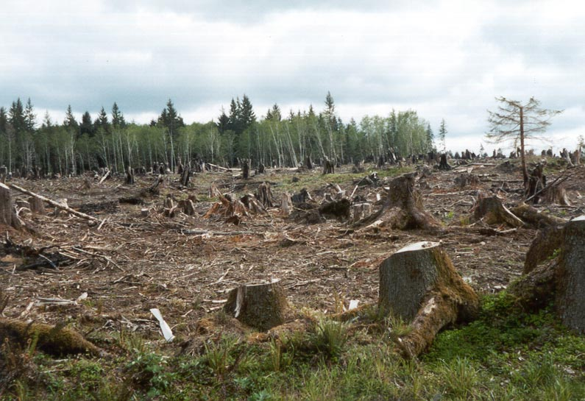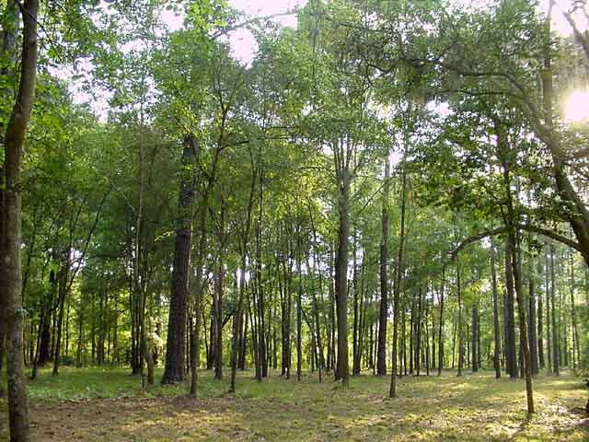

|  |  |  |  |  |
| --- | --- | --- | --- | --- |
| Positive Examples | | | Negative Examples | |
| nature 1.jpg | nature 2.jpg | | manmade 1.jpg | manmade 2.jpg |
| nature 3.jpg | | nature 4.jpg | manmade 3.jpg | manmade 4.jpg |
| nature 5.jpg | | nature 6.jpg | manmade 5.jpg | manmade 6.jpg |
| nature 7.jpg | | nature 8.jpg | manmade 7.jpg | manmade 8.jpg |
| nature 9.jpg | | nature 10.jpg |  |  |

Name:______________________________________________

Directions: Put a + by all positive examples and a – beside all negative (non-) examples.

|  |  |  |  |
| --- | --- | --- | --- |
| _____ | manmade 7.jpg | _____ | nature 8.jpg |
| _____ | manmade 3.jpg | _____ | manmade 2.jpg |
| ______ | nature 7.jpg |  |  |
|  |  |  |  |
|  |  |  |  |

What was I thinking of? ____________________________________________

Define it. __________________________________________________________ ____________________________________________________________________________________________________________________________________

Earth Day Thematic Unit: Day 3

**Course Data**

**Grade Level**: 3

**Lesson Topic**: Humans use of natural resources

**Materials**

Cookies (24)

Toothpicks

Student experiment journals

Chart paper

Markers

Peer evaluation form

Resource web worksheet

**Lesson Objectives**

TSWBAT conduct an experiment demonstrating the effects of mining on the land.

TSWBAT brainstorm the definition and examples of renewable and nonrenewable resources.

TSWBAT explain ways to conserve natural resources and the importance of conservation.

TSWBAT demonstrate equal participation, respect for ideas of others, and active listening in a group setting measured by a peer evaluation form.

TN curriculum standards

0307.7.5 Create a web that demonstrates the link between basic human needs and the earth’s resources.

**Anticipatory Set/Focus**

Experiment (pC37)

How does mining affect the land?

Procedure

1. Observe: Place the cookie on the paper towel. Draw the cookie in your experiment notes journal, and label its parts. The chips represent resources. The cookie represents the land.
2. Model: Use toothpicks to try to remove the chocolate chips. Try to remove them without damaging the rest of the cookie.
3. Experiment: Mine all the resources (chocolate chips) from the land (cookie).
4. Observe: Draw the cookie again.

Have students get into pairs and answer the following questions (write down answers in their journal).

1. How did mining change the cookie?
2. If you needed more resources than you found in the land, how could you get them?

Discuss answers as a class.

**Essential Question**: How is the earth affected by the influence of man?

I**nstruction**

Have students look at chapter 5 lesson 5.

Graffiti

***Step 1: Prepare the graffiti questions and group number and composition***

Graffiti Questions:

1. What is a renewable resource? Examples?
2. What is a nonrenewable resource? Examples?
3. How can you conserve resources?
4. Why does conserving matter?

***Step 2: Distribute materials***

Break students into 4 groups. Assign each group a writer and give them a marker (1 color for each group) and a piece of chart paper with the question on it.

***Step 3: Group answers question***

Give students 3-5 minutes with their question. Walk around and make sure that all students are contributing to the discussion.

***Step 4: Exchange questions***

After the 3-5 minutes, instruct the students to stop and recap their markers. Have one student from each group walk their paper to the group at their right. Repeat until all groups have had a chance to answer all 4 questions.

***Step 5: Return to original question, summarize, and make generalizations***

When the question that the group was originally working on gets back to them, have them look at the answers and have them make sure that they think all of the answers are correct. If they think one is wrong have them put an “X” beside of it. They will also write what human need is satisfied by each resource example.

***Step 6: Share information***

After they have had time to analyze the answers, they will select a presenter to stand up in front of the class and share their question and needs fulfilled.

***Step 7: Evaluate the group progress***

[in closure]

**Closure**

What did you guys learn with this activity? Did you like this activity? What did you like about it? What didn’t you like?

Have students complete the web about resources and human needs.

Assessment: Give students a peer evaluation form, take up experiment journals, and resource web.

**Accommodations/Differentiated Learning Experiences**

Mixed ability grouping.

Peer Evaluation Form

Name______________________________________________________

Directions: Write in the names of the members in your group. Score the members according to how they met each of the criteria listed at the top of the chart. Scoring: excellent (3), Satisfactory (2), Unsatisfactory (1).

|  |  |  |  |
| --- | --- | --- | --- |
| NAME: | Equal participation | Acceptance of ideas | Active listening |
| Self evaluation |  |  |  |
| 1. |  |  |  |
| 2. |  |  |  |
| 3. |  |  |  |
| 4. |  |  |  |

Peer Evaluation Form

Name______________________________________________________

Directions: Write in the names of the members in your group. Score the members according to how they met each of the criteria listed at the top of the chart. Scoring: excellent (3), Satisfactory (2), Unsatisfactory (1).

|  |  |  |  |
| --- | --- | --- | --- |
| NAME: | Equal participation | Acceptance of ideas | Active listening |
| Self evaluation |  |  |  |
| 1. |  |  |  |
| 2. |  |  |  |
| 3. |  |  |  |
| 4. |  |  |  |

Name:___________________________________________________

Directions: Fill in the web below. From the needs fulfilled circle, create circles describing what human needs each resource fulfills.

Earth Day Thematic Unit: Day 4

**Course Data**

**Grade Level**: 3

**Lesson Topic**: Reduce, Reuse, Recycle

**Materials**

<http://pbskids.org/eekoworld/index.html?load=garbage_recycling>

Scrap newspaper

Wire whisks

Water

Bucket

Square pans (at least 8 cm deep)

Pieces of window screens that fit inside the pan

Iron

Measuring cup

Towels

Dyes for coloring

**Lesson Objectives**

TSWBAT list ways to reduce and reuse items that would become trash.

TSWBAT identify materials that can be recycled.

TSWBAT create recycled paper.

TN curriculum standards

**GLE 0307.7.4** Design a simple investigation to demonstrate how earth materials can be conserved or recycled.

**Anticipatory Set/Focus**

(Tear newspaper and begin soaking in hot water before set.)

What renewable resource are we helping to re-grow this week? (ABK, RRL). Why is that resource important to humans? Planting trees is one way that you can help the earth, but there are other things that you can do to help the environment. The video that you are about to watch helps to show you some of them. (Show students the video about recycling <http://pbskids.org/eekoworld/index.html?load=garbage_recycling>) (IAL).

While watching the video have students answer the following questions:

1. Name 3 ways that you can reduce the amount of garbage you produce.
2. Name 3 things that you can reuse.
3. Name three things that can be recycled.

Discuss as a class and make a list of each on the board.

Today, we are going to help the environment by recycling our own paper! (LL)

**Essential Question**: How can we help save our natural resources?

I**nstruction**

Break students into groups of three.

Making Paper:

1. Tear the scrap paper into tiny pieces and soak them in a bucket of hot water for about 30 minutes. (Complete prior to lesson so it is soaking during the set of lesson.) Using a whisk, have students beat the mixture until it is a creamy pulp. Give students a selection of dye to add for color.
2. One at a time, one student from the group will pour the blended pulp into a measuring cup. Pour roughly 3 cm of water into the pan. Put the screen into the pan and pour one cup of the paper pulp onto the screen.
3. That student will then spread the pulp evenly in the water with your fingers. It should feel kind of mushy. Lift the screen and let the water drain.
4. The student will then lay the pulp-covered screen face down on a cloth or in between some newspaper. Lift the screen away, leaving the paper pulp on the cloth. Cover with another cloth. The instructor will then come around and iron the paper.
5. The next student in the group will then repeat steps 2-4.
6. After the pulp has been ironed, the students will place their pulp in the towels at the back of the classroom. A piece of tape with the child’s name will be placed on the paper. The paper will remain there to dry overnight.

**Closure**

What did what we did today have to do with saving our natural resources? What are other ways that we talked about today to save resources and reduce our trash production? Did you have fun being a part of the recycling process today?

Assessment: Collect questions, check that all students have created paper.

Earth Day Thematic Unit: Day 5

**Course Data**

**Grade Level**: 3

**Lesson Topic**: Earth day centers/ Review

**Anticipatory Set/Focus**

Value line: Everyone think about what we have been talking this week and whether you think that you can have a positive impact on the environment (ABK, RRL). Write down a number one through ten. A one means that you think you can have no impact and a ten means that you think you can have an incredible impact. Now line up at the front of the room starting with ones and going to tens (IAL). Today, we are going to review the topics we covered by doing Earth Day center (LL).

**Essential Question**: Can we make an impact?

I**nstruction**

***Center 1: Trees!***

Materials: recycled paper, markers, pencil, flipbook example, flipbook intructions

Objectives:

TSWBAT describe the benefits of trees.

TSWBAT illustrate a forest altered by humans.

TSWBAT classify trees as a renewable or non-renewable resource.

TSWBAT list the materials trees provide.

TSWBAT identify ways to reduce, reuse, and recycle materials made from trees.

TSWBAT create a flipbook about trees.

Using the recycled paper that you made the day before, make a flipbook using the directions below.

Also, provide an example flipbook for the children.

***Center 2: Human’s influence on the environment***

Materials: white paper, markers or crayons to color,

Objectives:

TSWBAT illustrate an environment before and after human influence.

TSWBAT distinguish between natural and man-made objects.

TSWBAT describe the influence humans have on an environment.

Fold a sheet of white paper in half and then open it back up. On the top part of the paper write before and on the bottom part write after. Now, draw an environment before the influence of humans on the top. Make sure that you include only natural objects. On the bottom, draw that same environment after human influence. Make sure that you include several man-made objects. On the back of the paper write a paragraph about how humans have changed the environment you selected.

***Center 3: Natural Resources***

Materials: sort worksheet, scissors, glue

Objectives:

TSWBAT define renewable and nonrenewable resources.

TSWBAT sort resources as either renewable or non renewable

Have students complete the word sort worksheet.

***Center 4: Reduce, Resuse, Recycle***

Materials: computer, paper, Eekoworld’s Eekohouse (<http://pbskids.org/eekoworld/index.html?load=eekohouse>),

Objectives:

TSWBAT apply knowledge about reducing, reusing, and recycling in a real world setting.

TSWBAT compose a paragraph describing three things they can do at their house to reduce, reuse, or recycle.

Enter the Eekoworld website at [www.eekoworld.com](http://www.eekoworld.com). Then, click on the EekoHouse.

Record your score from the Eekohouse on the top of a piece of paper. Then, write a paragraph about 3 things you can do around your house to reduce, reuse, or recycle.

**Closure**

Redo value line. Did anyone’s number change from the first one? Remind students that we planted a tree this week which will make a difference. Have each student name one thing they can do you help.

Assessment: (1) take up flipchart, (2) take up illustrations and paragraph, (3) take up word sort worksheet, and (4) take up paragraph with EekoHouse score.

**Flipbook Directions.**

|  |  |  |
| --- | --- | --- |
| 1 |  | Fold the paper in half hotdog style. |
| 2 |  | Fold the paper in half again and then that half in half one time. |
| 3 |  | Open the paper back up like the picture to the left. The paper should be divided into four sections with creases. Open the paper up all the way. |
| 4 |  | Cut the paper where the dotted lines on the left are. MAKE SURE NOT TO CUT ALL THE WAY ACROSS! Fold the book back in half and use the flipbook below as a reference |

Front/ outside

|  |  |  |  |
| --- | --- | --- | --- |
| **Benefits of Trees**  Draw a tree here. | **Humans effect on trees**  Draw a forest unaltered by humans | **Trees as a resource**  Draw a resource trees provide | **Reduce, Reuse, Recycle trees**  Draw the reduce, reuse, recycle symbol |

Inside

|  |  |  |  |
| --- | --- | --- | --- |
| In this block, describe the benefits of trees | In this block, illustrate a forest altered by humans. | In this block, list the materials trees provide. Identify trees as renewable or nonrenewable | In this block, describe ways we can reduce, reuse, and recycle materials made from trees |

Name:_____________________________________________________

Directions: Write the definition of renewable and non-renewable resources. Then, cut the words out below and glue them under the correct column and write the need each satisfies.

|  |  |  |  |
| --- | --- | --- | --- |
| **Renewable resources** | | **Nonrenewable resource** | |
| Definition: | | Definition: | |
| **Resource** | **Need** | **Resource** | **Need** |
|  |  |  |  |
|  |  |  |  |
|  |  |  |  |
|  |  |  |  |

|  |  |  |  |
| --- | --- | --- | --- |
| soil | iron | animals | coal |
| oil | water | plants | copper |